**A.KPI**

**1.Total Revenue**

SELECT SUM(total_price) AS Total_Revenue FROM pizza_sales

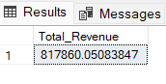

**2. Average Order Value**

SELECT SUM(total_price) / COUNT(DISTINCT order_id) AS Avg_Order_Value FROM pizza_sales

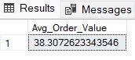

**3.Totsl Pizza’s Sold**

SELECT SUM(quantity) AS Tot_Pizza_Sold FROM pizza_sales

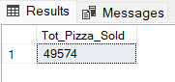

**4.Total Orders**

SELECT COUNT(DISTINCT order_id) AS Total_Orders FROM pizza_sales

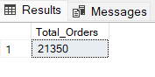

**5.Average Pizza’s per Order**

SELECT CAST(CAST(SUM(quantity) AS DECIMAL(10,2)) / CAST(COUNT(DISTINCT order_id)

AS DECIMAL(10,2)) AS DECIMAL(10,2)) as Avg_Pizza_per_Order FROM pizza_sales

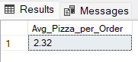

**B.CHARTS**

**1.Daily Trend for Total Orders**

SELECT DATENAME(DW, order_date) AS order_day, COUNT(DISTINCT order_id) AS Total_orders FROM pizza_sales GROUP BY DATENAME(DW, order_date)

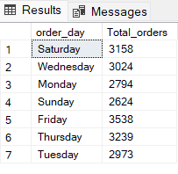

**2.Monthly Trend for Total Orders**

SELECT DATENAME(MONTH, order_date) AS Month_Name, COUNT(DISTINCT order_id) AS Total_Order FROM pizza_sales

GROUP BY DATENAME(MONTH, order_date)

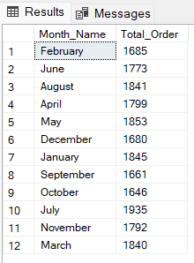

**3.Percentage of Sales by Pizza Category**

SELECT pizza_category AS Category,

CAST(SUM(total_price) AS DECIMAL(10,2)) AS Total_sales,

CAST(SUM(total_price) * 100 / (SELECT SUM(total_price) FROM pizza_sales) AS DECIMAL(10,2)) AS perc_sales_by_category

FROM pizza_sales

GROUP BY pizza_category

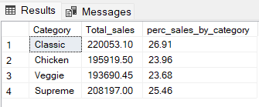

**4.Percentage of Sales by Pizza Size**

SELECT pizza_size AS Size,

CAST(SUM(total_price) AS DECIMAL(10,2)) AS Total_sales,

CAST(SUM(total_price) * 100 / (SELECT SUM(total_price) FROM pizza_sales) AS DECIMAL(10,2)) AS perc_sales_by_size

FROM pizza_sales

GROUP BY pizza_size

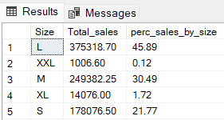

**5.Top 5 Pizzas by Revenue**

SELECT TOP 5 pizza_name, SUM(total_price) AS Total_Revenue FROM pizza_sales

GROUP BY pizza_name

ORDER BY Total_Revenue DESC

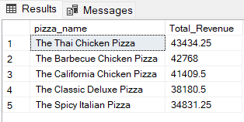

**6.Bottom 5 pizzas by Revenue**

SELECT TOP 5 pizza_name, SUM(total_price) AS Total_Revenue FROM pizza_sales

GROUP BY pizza_name

ORDER BY Total_Revenue ASC

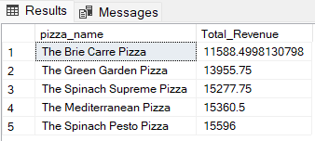

**7.Top 5 Pizzas by Quantity**

SELECT TOP 5 pizza_name, SUM(quantity) AS Total_Quantity FROM pizza_sales

GROUP BY pizza_name

ORDER BY Total_Quantity DESC

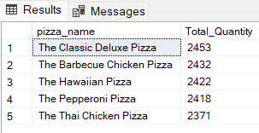

**8.Bottom 5 pizzas by Quantity**

SELECT TOP 5 pizza_name, SUM(quantity) AS Total_Quantity FROM pizza_sales

GROUP BY pizza_name

ORDER BY Total_Quantity ASC

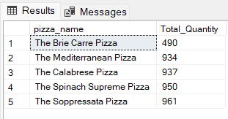

**9.Top 5 pizzas by Orders**

SELECT TOP 5 pizza_name, COUNT(distinct order_id) AS Total_Order FROM pizza_sales

GROUP BY pizza_name

ORDER BY Total_Order DESC

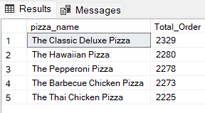

**10.Bottom 5 Pizzas by Orders**

SELECT TOP 5 pizza_name, COUNT(distinct order_id) AS Total_Order FROM pizza_sales

GROUP BY pizza_name

ORDER BY Total_Order ASC

